**WEEK-7 REACT APPLICATION**

**React-App 1 :**

IndianPlayers :

import React from "react";

function IndianPlayers() {

  // Odd and even team players using destructuring

  const players = ["Rohit", "Virat", "Gill", "Ishan", "Hardik", "Jadeja"];

  const [p1, p2, p3, p4, p5, p6] = players;

  const oddTeam = [p1, p3, p5];

  const evenTeam = [p2, p4, p6];

  // Merging two arrays using spread operator

  const T20players = ["Surya", "Rinku", "Samson"];

  const RanjiTrophyPlayers = ["Rahane", "Pujara", "Umesh"];

  const allPlayers = [...T20players, ...RanjiTrophyPlayers];

  return (

    <div>

      <h2>Odd Team Players</h2>

      <ul>

        {oddTeam.map((player, index) => (

          <li key={index}>{player}</li>

        ))}

      </ul>

      <h2>Even Team Players</h2>

      <ul>

        {evenTeam.map((player, index) => (

          <li key={index}>{player}</li>

        ))}

      </ul>

      <h2>All Merged Players (T20 + Ranji)</h2>

      <ul>

        {allPlayers.map((player, index) => (

          <li key={index}>{player}</li>

        ))}

      </ul>

    </div>

  );

}

export default IndianPlayers;

ListOfPlayers :

import React from "react";

function ListOfPlayers() {

  const players = [

    { name: "Rohit", score: 80 },

    { name: "Virat", score: 95 },

    { name: "Gill", score: 65 },

    { name: "Ishan", score: 45 },

    { name: "Hardik", score: 78 },

    { name: "Jadeja", score: 60 },

    { name: "Bumrah", score: 30 },

    { name: "Shami", score: 55 },

    { name: "Kuldeep", score: 40 },

    { name: "Siraj", score: 70 },

    { name: "Pant", score: 50 }

  ];

  // Filter players with score < 70 using arrow function

  const lowScorers = players.filter(p => p.score < 70);

  return (

    <div>

      <h2>All Players</h2>

      <ul>

        {players.map((player, index) => (

          <li key={index}>{player.name} - {player.score}</li>

        ))}

      </ul>

      <h2>Players with Score &lt; 70</h2>

      <ul>

        {lowScorers.map((player, index) => (

          <li key={index}>{player.name} - {player.score}</li>

        ))}

      </ul>

    </div>

  );

}

export default ListOfPlayers;

App.js :

import React from "react";

import ListOfPlayers from "./components/ListOfPlayers";

import IndianPlayers from "./components/IndianPlayers";

function App() {

  const flag = true; // change to false to show IndianPlayers

  return (

    <div className="App">

      <h1 style={{ color: "#00A36C" }}>🏏 Welcome to Cricket App</h1>

      {flag ? <ListOfPlayers /> : <IndianPlayers />}

    </div>

  );

}

export default App;

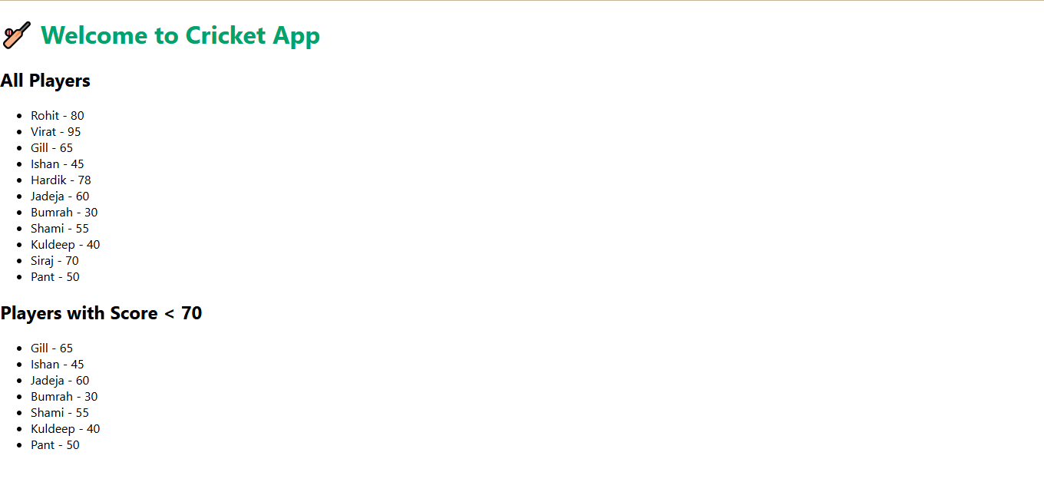

**React-App 2 :**

App.js :

import React from "react";

function App() {

  // Object for a single office

  const office = {

    name: "GreenTech Tower",

    rent: 55000,

    address: "No.10, Anna Salai, Chennai",

    image: "https://via.placeholder.com/300x200?text=Office+Space"

  };

  // List of offices

  const officeList = [

    {

      name: "GreenTech Tower",

      rent: 55000,

      address: "No.10, Anna Salai, Chennai",

      image: "https://via.placeholder.com/200x120?text=GreenTech"

    },

    {

      name: "Skyline Plaza",

      rent: 75000,

      address: "Block B, Bangalore",

      image: "https://via.placeholder.com/200x120?text=Skyline"

    },

    {

      name: "EcoSpace",

      rent: 40000,

      address: "Sector 22, Hyderabad",

      image: "https://via.placeholder.com/200x120?text=EcoSpace"

    }

  ];

  return (

    <div>

      {/* JSX Heading */}

      <h1 style={{ textAlign: "center", color: "#00A36C" }}>

        🏢 Office Space Rental App

      </h1>

      {/* React.createElement Example */}

      {React.createElement("h2", null, "Single Office Details")}

      {/* Display single office using JSX and object */}

      <div

        style={{

          border: "1px solid gray",

          padding: "10px",

          margin: "10px",

          borderRadius: "10px"

        }}

      >

        <img src={office.image} alt={office.name} />

        <h3>{office.name}</h3>

        <p>Address: {office.address}</p>

        <p style={{ color: office.rent < 60000 ? "red" : "green" }}>

          Rent: ₹{office.rent}

        </p>

      </div>

      {/* Display list of office items */}

      <h2>All Available Offices</h2>

      {officeList.map((item, index) => (

        <div

          key={index}

          style={{

            border: "1px solid #ccc",

            marginBottom: "10px",

            padding: "10px",

            borderRadius: "10px"

          }}

        >

          <img src={item.image} alt={item.name} />

          <h3>{item.name}</h3>

          <p>{item.address}</p>

          <p style={{ color: item.rent < 60000 ? "red" : "green" }}>

            Rent: ₹{item.rent}

          </p>

        </div>

      ))}

    </div>

  );

}

export default App;

index.css :

body {

    margin: 0;

    padding: 20px;

    font-family: Arial, sans-serif;

    background-color: #f0f0f0;

}

Index.js :

import React from 'react';

import ReactDOM from 'react-dom/client';

import App from './App';

import './index.css'; // Optional for global styles

const root = ReactDOM.createRoot(document.getElementById('root'));

root.render(<App />);

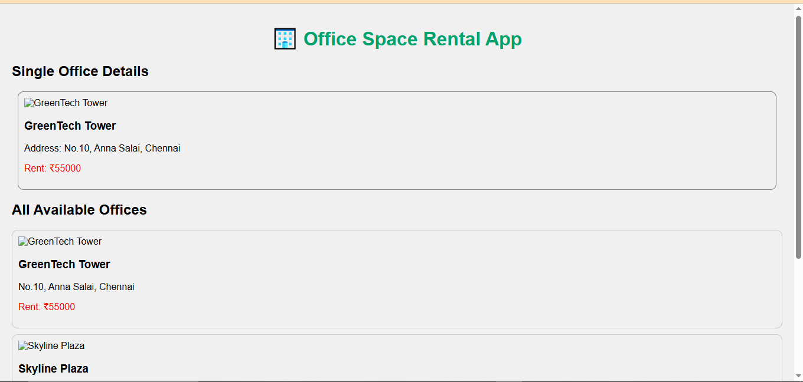

**React-App 3 :**

Counter.js :

import React, { Component } from 'react';

class Counter extends Component {

  constructor() {

    super();

    this.state = {

      count: 0

    };

  }

  increment = () => {

    this.setState({ count: this.state.count + 1 });

    this.sayHello(); // invoking multiple methods

  };

  decrement = () => {

    this.setState({ count: this.state.count - 1 });

  };

  sayHello = () => {

    console.log("Hello! This is a static message.");

  };

  sayWelcome = (message) => {

    alert("Message: " + message);

  };

  handleClick = (e) => {

    alert("I was clicked!"); // Synthetic Event

    console.log(e); // React Synthetic Event Object

  };

  render() {

    return (

      <div>

        <h2>Counter Value: {this.state.count}</h2>

        <button onClick={this.increment}>Increment</button>

        <button onClick={this.decrement}>Decrement</button>

        <button onClick={() => this.sayWelcome("Welcome!")}>Say Welcome</button>

        <button onClick={this.handleClick}>Synthetic Event Button</button>

      </div>

    );

  }

}

export default Counter;

CurrencyCovertor.js :

import React, { useState } from 'react';

function CurrencyConvertor() {

  const [rupees, setRupees] = useState("");

  const [euro, setEuro] = useState("");

  const handleSubmit = () => {

    const result = parseFloat(rupees) / 90;

    setEuro(result.toFixed(2));

  };

  return (

    <div>

      <h2>Currency Converter (INR → EURO)</h2>

      <input

        type="text"

        value={rupees}

        onChange={(e) => setRupees(e.target.value)}

        placeholder="Enter INR"

      />

      <button onClick={handleSubmit}>Convert</button>

      {euro && <p>Converted Euro: €{euro}</p>}

    </div>

  );

}

export default CurrencyConvertor;

App.css :

.App {

    text-align: center;

    padding: 20px;

}

button {

    margin: 5px;

    padding: 10px;

    font-size: 16px;

}

App.js :

import React from 'react';

import Counter from './components/Counter';

import CurrencyConvertor from './components/CurrencyConvertor';

function App() {

  return (

    <div className="App">

      <h1>🎯 React Event Handling Examples</h1>

      <Counter />

      <hr />

      <CurrencyConvertor />

    </div>

  );

}

export default App;

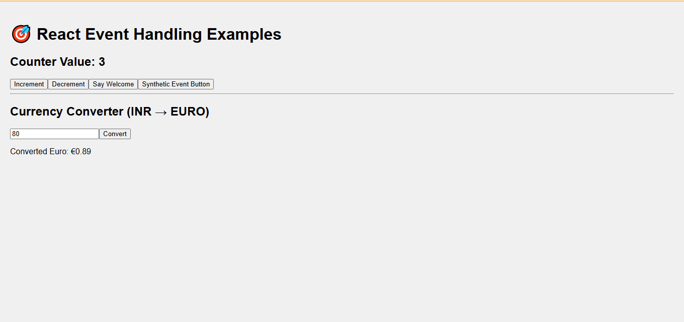

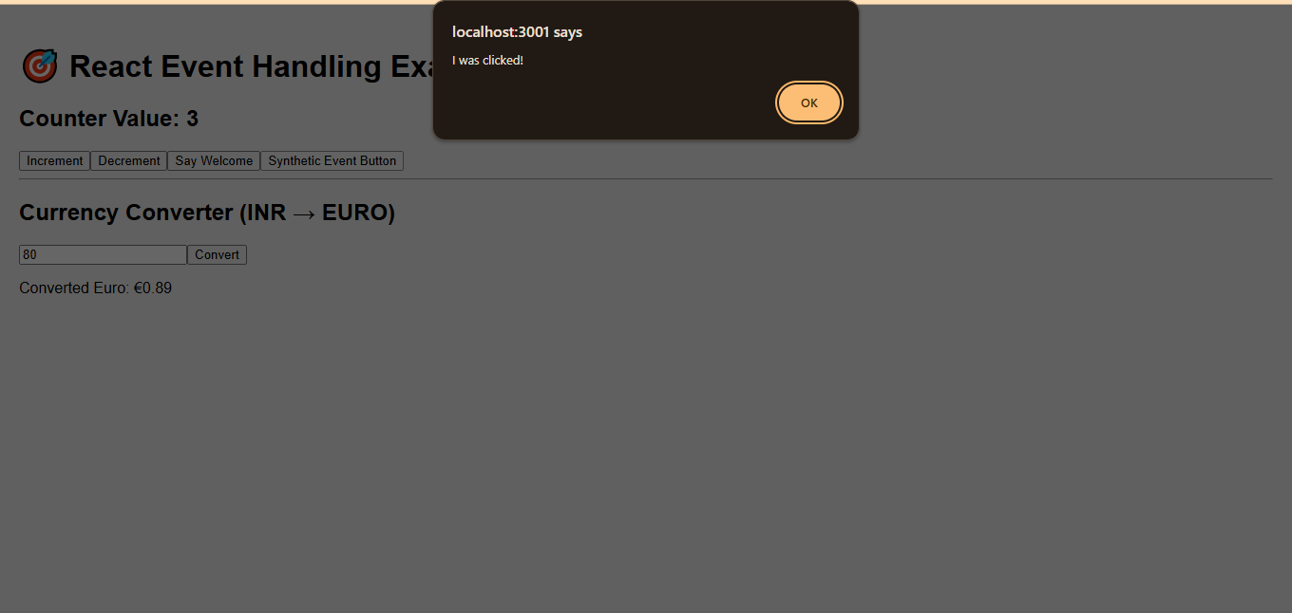

**React-App 4 :**

GuestPage.js :

// src/components/GuestPage.js

import React from 'react';

function GuestPage({ onLogin }) {

  return (

    <div>

      <h2>Welcome, Guest!</h2>

      <p>🛫 Flight Details: Chennai ✈ Delhi — ₹5,000</p>

      <button onClick={onLogin}>Login to Book</button>

    </div>

  );

}

export default GuestPage;

UserPage.js :

// src/components/UserPage.js

import React from 'react';

function UserPage({ onLogout }) {

  return (

    <div>

      <h2>Welcome, User!</h2>

      <p>🛫 Book your ticket: Chennai ✈ Delhi — ₹5,000</p>

      <button>Book Now</button>

      <br /><br />

      <button onClick={onLogout}>Logout</button>

    </div>

  );

}

export default UserPage;

App.css :

.App {

    text-align: center;

    padding: 2rem;

    font-family: sans-serif;

}

button {

    padding: 10px 20px;

    font-size: 16px;

    margin: 10px;

}

App.js :

// src/App.js

import React, { useState } from 'react';

import GuestPage from './components/GuestPage';

import UserPage from './components/UserPage';

function App() {

  const [isLoggedIn, setIsLoggedIn] = useState(false);

  // Define login/logout handlers

  const handleLogin = () => setIsLoggedIn(true);

  const handleLogout = () => setIsLoggedIn(false);

  // Element variable for conditional rendering

  let content;

  if (isLoggedIn) {

    content = <UserPage onLogout={handleLogout} />;

  } else {

    content = <GuestPage onLogin={handleLogin} />;

  }

  return (

    <div className="App">

      <h1>✈️ Ticket Booking App</h1>

      {content}

    </div>

  );

}

export default App;

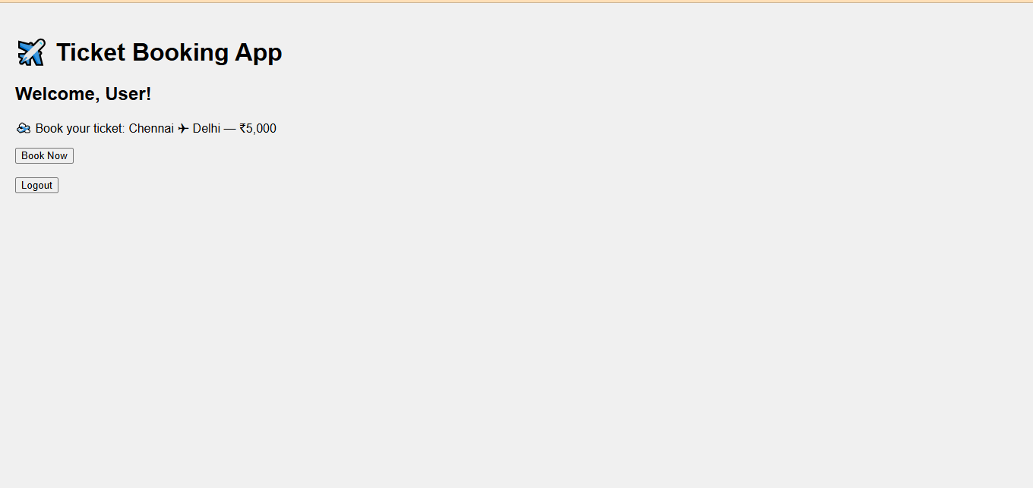

**React-App 5 :**

BlogDetails.js :

// src/components/BlogDetails.js

import React from 'react';

const blogs = [

  { id: 1, title: 'React Hooks Deep Dive' },

  { id: 2, title: 'Advanced JavaScript Concepts' },

];

function BlogDetails() {

  return (

    <div>

      <h2>📝 Blog Details</h2>

      <ul>

        {blogs.map((blog) => (

          <li key={blog.id}>{blog.title}</li>

        ))}

      </ul>

    </div>

  );

}

export default BlogDetails;

BookDetails.js :

// src/components/BookDetails.js

import React from 'react';

const books = [

  { id: 1, title: 'Learn React', author: 'Dan Abramov' },

  { id: 2, title: 'JavaScript Mastery', author: 'Kyle Simpson' },

];

function BookDetails() {

  return (

    <div>

      <h2>📚 Book Details</h2>

      <ul>

        {books.map((book) => (

          <li key={book.id}>

            <b>{book.title}</b> - {book.author}

          </li>

        ))}

      </ul>

    </div>

  );

}

export default BookDetails;

App.js :

// src/App.js

import React, { useState } from 'react';

import BookDetails from './components/BookDetails';

import BlogDetails from './components/BlogDetails';

import CourseDetails from './components/CourseDetails';

function App() {

  const [view, setView] = useState('book');

  // Element variable example

  let content;

  if (view === 'book') content = <BookDetails />;

  else if (view === 'blog') content = <BlogDetails />;

  else content = <CourseDetails />;

  return (

    <div className="App">

      <h1>📘 Blogger App</h1>

      {/* Buttons to switch */}

      <div>

        <button onClick={() => setView('book')}>Books</button>

        <button onClick={() => setView('blog')}>Blogs</button>

        <button onClick={() => setView('course')}>Courses</button>

      </div>

      <hr />

      {/* Method 1: Element Variable */}

      {content}

      {/* Method 2: Ternary Operator */}

      {/* {view === 'book' ? <BookDetails /> : view === 'blog' ? <BlogDetails /> : <CourseDetails />} */}

      {/* Method 3: Logical AND */}

      {/* {view === 'book' && <BookDetails />}

      {view === 'blog' && <BlogDetails />}

      {view === 'course' && <CourseDetails />} */}

    </div>

  );

}

export default App;

